JDA Client Installation

This is to install JDA application.

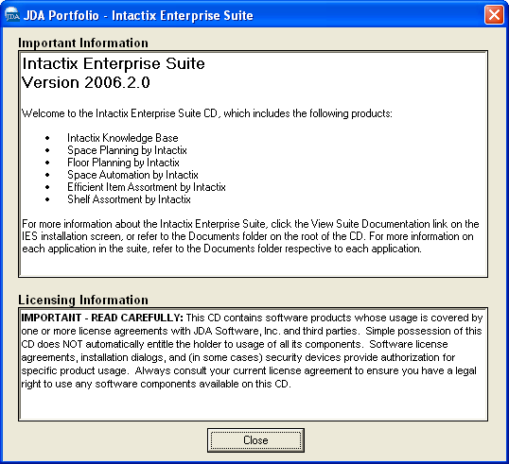
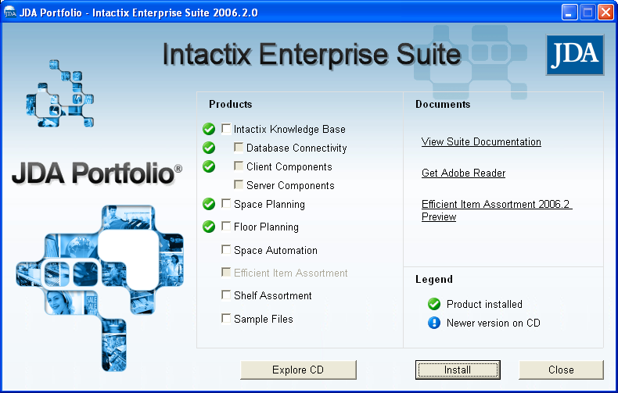

Select the appropriate application you want to install

- Intactix Knowledge Base
- Database Connectivity
- Client Components

- Space Planning
- Floor Planning

JDA Activation Codes
USER ID = TESCO PLC
Space Planning Plus = 566310
Floor Planning Plus = 537710
IKB = 711410
IKB Net (Web Publisher) = 143906

Once Pro Space, Floor Planning and IKB Data Manager are installed configure the client with the following.

Pro Space Client Configurations
Copy the following files to their appropriate locations
ProSpace.ini  Config files | C:\Program Files\JDA\Intactix\Space Planning
Prospace.aut  Authorization files, write to POGs etc. | C:\Program Files\JDA\Intactix\Space Planning
Prospace.pmd  Command settings within ProSpace | C:\Program Files\JDA\Intactix\Space Planning
Copy the following folders to their appropriate locations
Layout | C:\Program Files\JDA\Intactix\Space Planning
Table | C:\Program Files\JDA\Intactix\Space Planning
Floor Planning Client Configurations
Copy the following files to their appropriate locations
ProFloor.ini  Config files | C:\Program Files\JDA\Intactix\Floor Planning
ProFloor.aut  Authorization files, write to Floorplans etc. | C:\Program Files\JDA\Intactix\Floor Planning
ProFloor.pmd  Command settings within ProSpace | C:\Program Files\JDA\Intactix\Floor Planning
Copy the following folders to their appropriate locations
Layout | C:\Program Files\JDA\Intactix\Floor Planning
Table | C:\Program Files\JDA\Intactix\Floor Planning
IKB Configurations
Copy the following folders to their appropriate locations
CSG Controls  Once the folders are copied execute register.bat in the sub-folder, this will register the OCX files | C:\Program Files\JDA\Intactix\Intactix Knowledge Base\CSGControls

